**EXP 2)**Create a simple cloud software application for Property Buying & Rental process (In Chennai city) using any Cloud Service Provider to demonstrate SaaS include the necessary fields such as Buy, Rent, commercial, Rental Agreement , Rental Agreement, Area, place, Range, property value etc.

**PROCEDURE:**

**STEP1:** GOTO ZOHO.COM

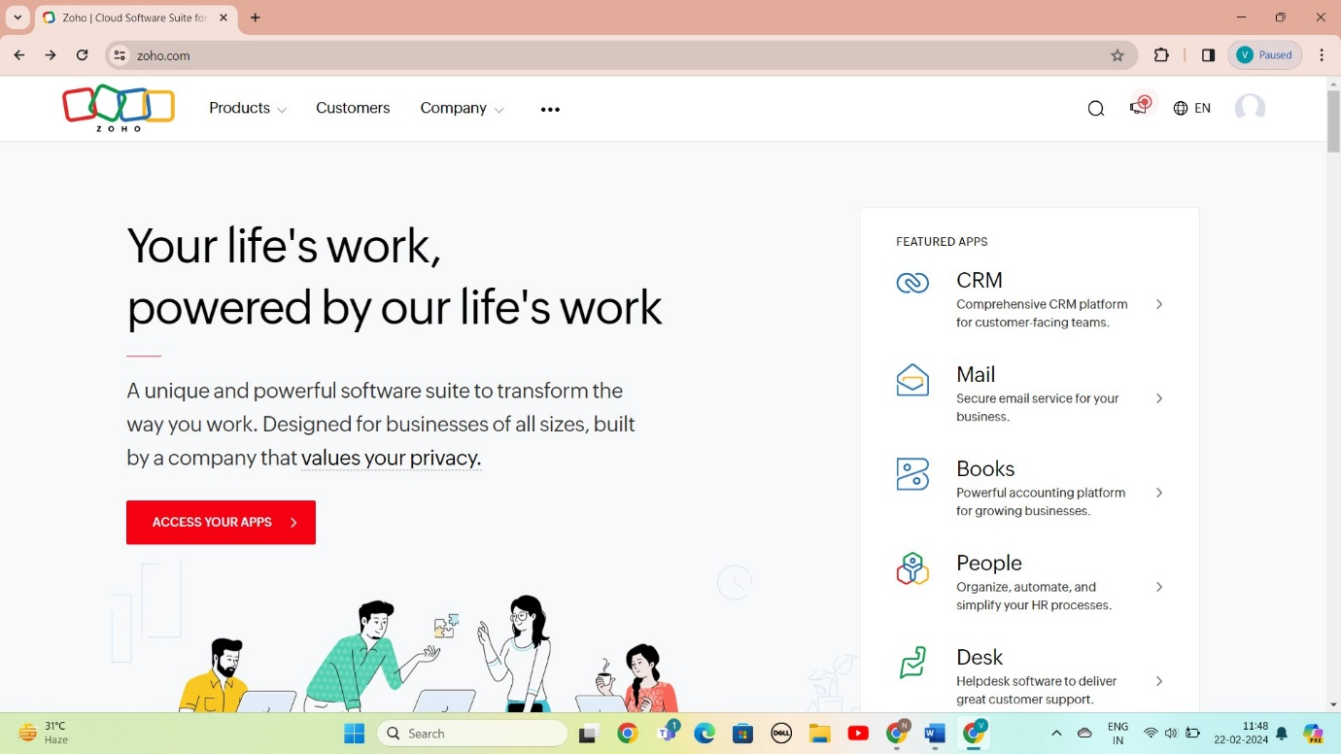

STEP 2: LOGIN TO THE ZOHO.COM

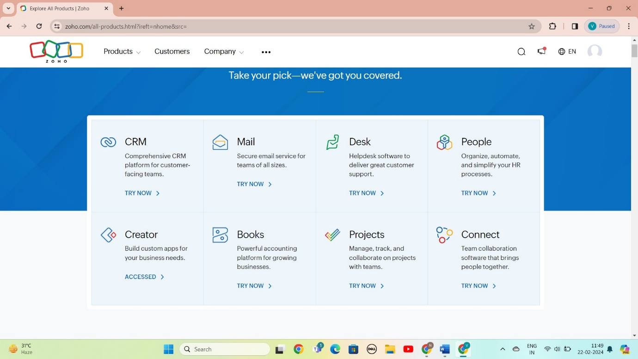

STEP 3: SELECT A CREATE FROM SCRATCH

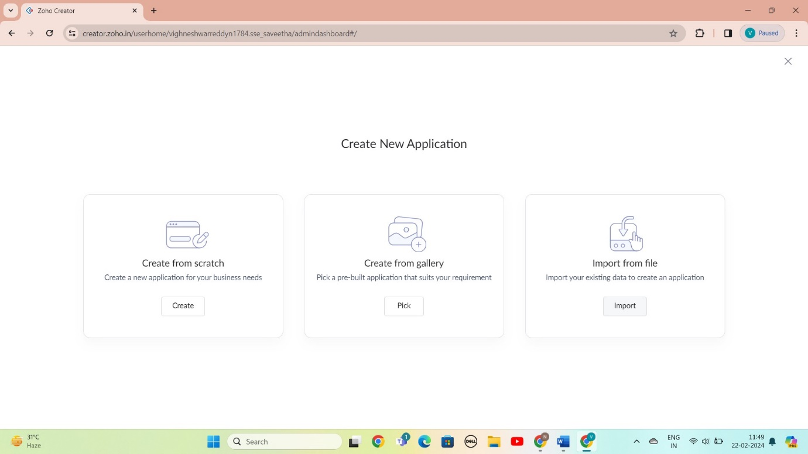

STEP 4: SELECT APPLICATION NAME AS PROPERTY BUYING AND RENTAL SYSTEM

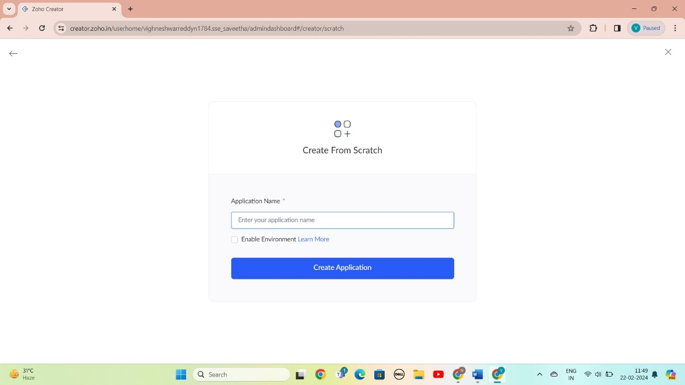

STEP 5: CREATED NEW FORM

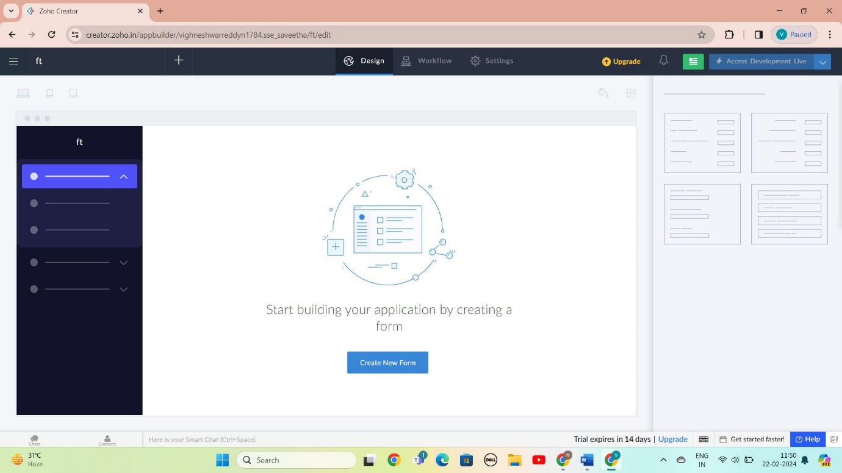

STEP 6: SELECT BASIC FILED FROM GIVEN BELOW AND DEVELOP APPLICATION

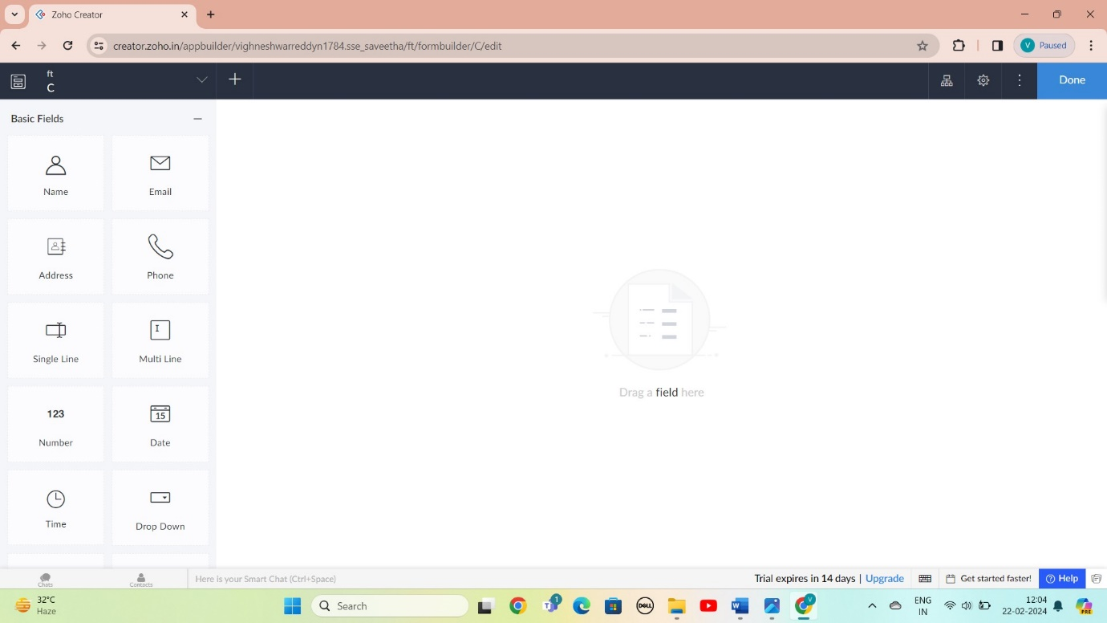

STEP 7: : THE SOFTWARE AS BEEN CREATE LOGIN

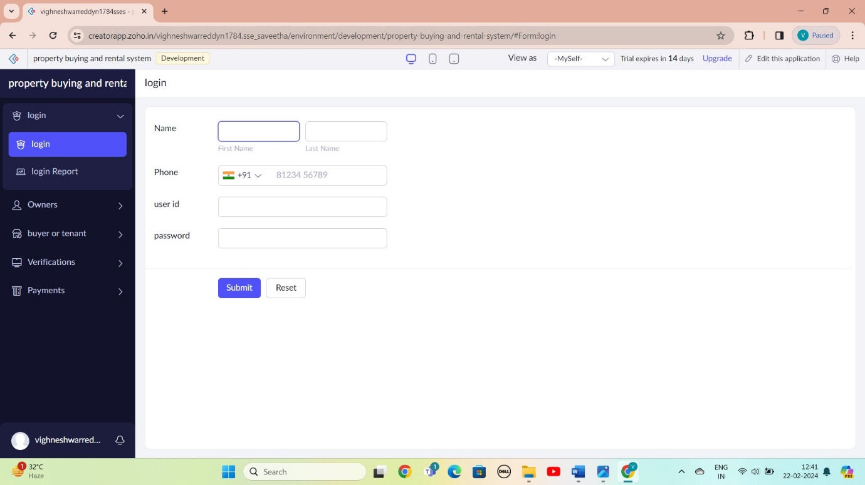

STEP 8: : THE SOFTWARE AS BEEN CREATE OWNER

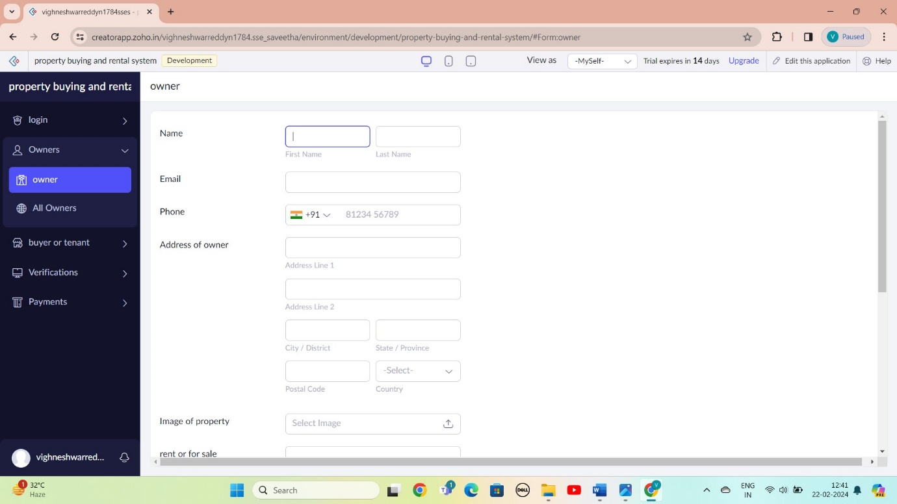

STEP 9: THE SOFTWARE AS BEEN CREATE BUYER OR TENANT

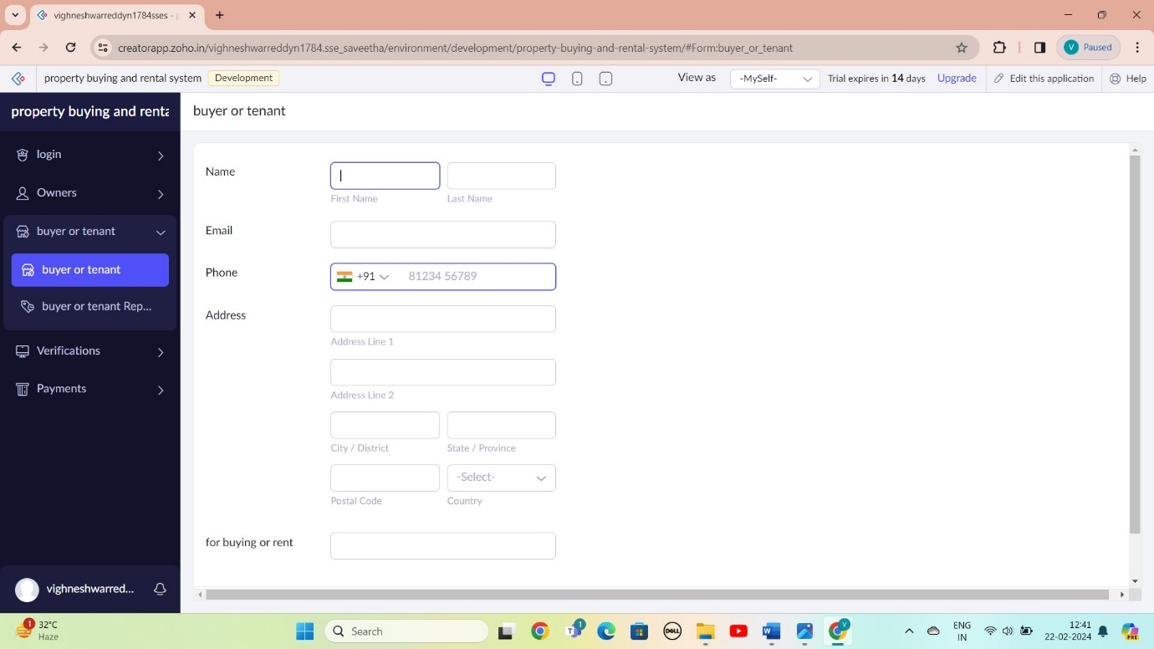

STEP 10: THE SOFTWARE AS BEEN CREATE VERIFICATION

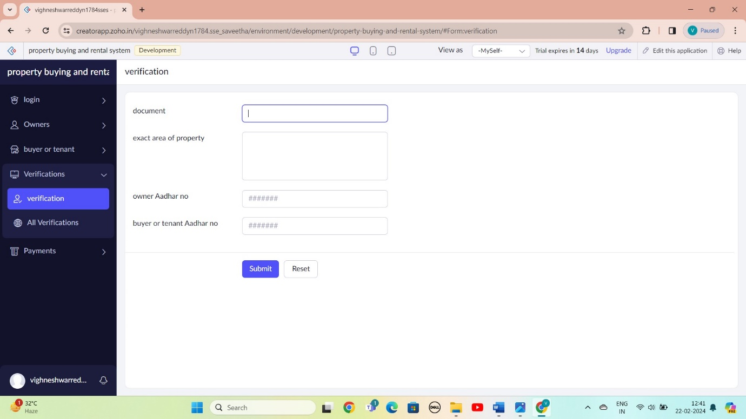

STEP 11: THE SOFTWARE AS BEEN CREATE PAYMENTS

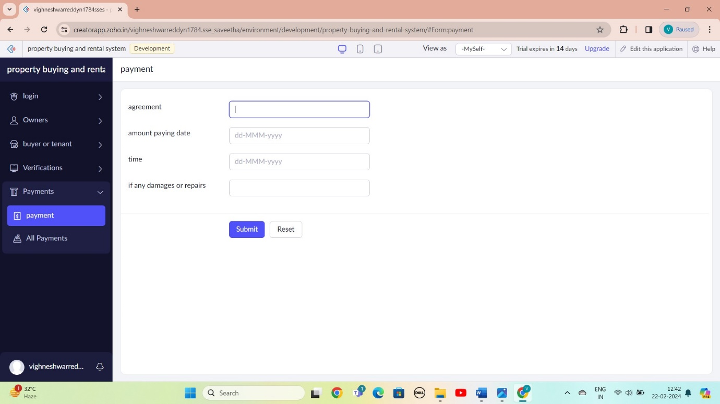

STEP 12: THE SOFTWARE AS BEEN CREATE

